Oklahoma Business Ethics Consortium
February 14, 2007 ~ 11:30 to 1:00
Agenda

I. WELCOME & KUDOS Shannon Hiebert, Enterprise Rent-A-Car, OkEthics State Council President & Conference Chair
  - Connie Barwick – Maximum Multi Media Creations for the pre-meeting Power Point presentations
Special note: Connie is now responsible for processing OkEthics invoices & monitoring website activities.
  - Greg Byers & Mary Kay Huggard with Principal Technologies Inc. for spearheading our
registration process
  - Joshua Jantz with Character First! for preparing the name tags.
  - Justin Meek with Cicero International Advertising for his continued service – additional Constituency
Directories are available at the registration table for guests.
  - Legacy Leadership Team Members! Thank you for directing our future!
  - Blaine Rider with Digital West for preparing the upcoming promotional video.

- CONFERENCE HIGHLIGHTS – SAVE THE DATE: APRIL 25!!! Shannon Hiebert, Chairperson
  - Skirvin Hilton Hotel
  - Spirit Bank’s Eddie Sutton is Keynote Speaker
  - Boeing’s Vice President: Sam Jenkins
  - Panel of University Presidents, Provosts & Deans
  - Executive Panel from Compass Award finalists
  - Watch for details on our website – coming soon!
Sponsorships available: Contact Shannon Hiebert at 330-9191 or Susan Leonard at 917-1773.

III. video Promo – Watch this fast-moving vignette describing last year’s event!
Corrections: Express Personnel’s Cindy Fairchild presented the third scholarship, not Enterprise;
Valir Health is the 2006 Compass Award recipient for the mid-sized company category. Our apologies!

iv. Compass Awards Shannon Warren, OkEthics Founding Director
Deadline for notices is 2/28; applications must be submitted by 3/30.Application and details on process are available on the website at www.okethics.org; or call (405) 858-2233.
  - Compass Awards will be held in conjunction with our first state conference
Large company = $800 for table of 8; Midsize company = $600; Small company = $300
  - Our outstanding Judges Panel includes Mike Strong and Sherri Smith-Gray of the Oklahoma Quality Award Foundation; Kim Holland, Insurance Commissioner; Edith Steele of the Oklahoma Accountancy Board; Oscar Jackson, a member of Governor Henry’s cabinet; Dottie Overal with the Small Business Administration – and many others!
  - Scholarship Awards from our Star members will be presented - $500 to $5,000 (OCU Meinders)
Visit our website or contact our OkEthics Foundation President, Bob Byrne, for details: robert.j.byrne@boeing.com
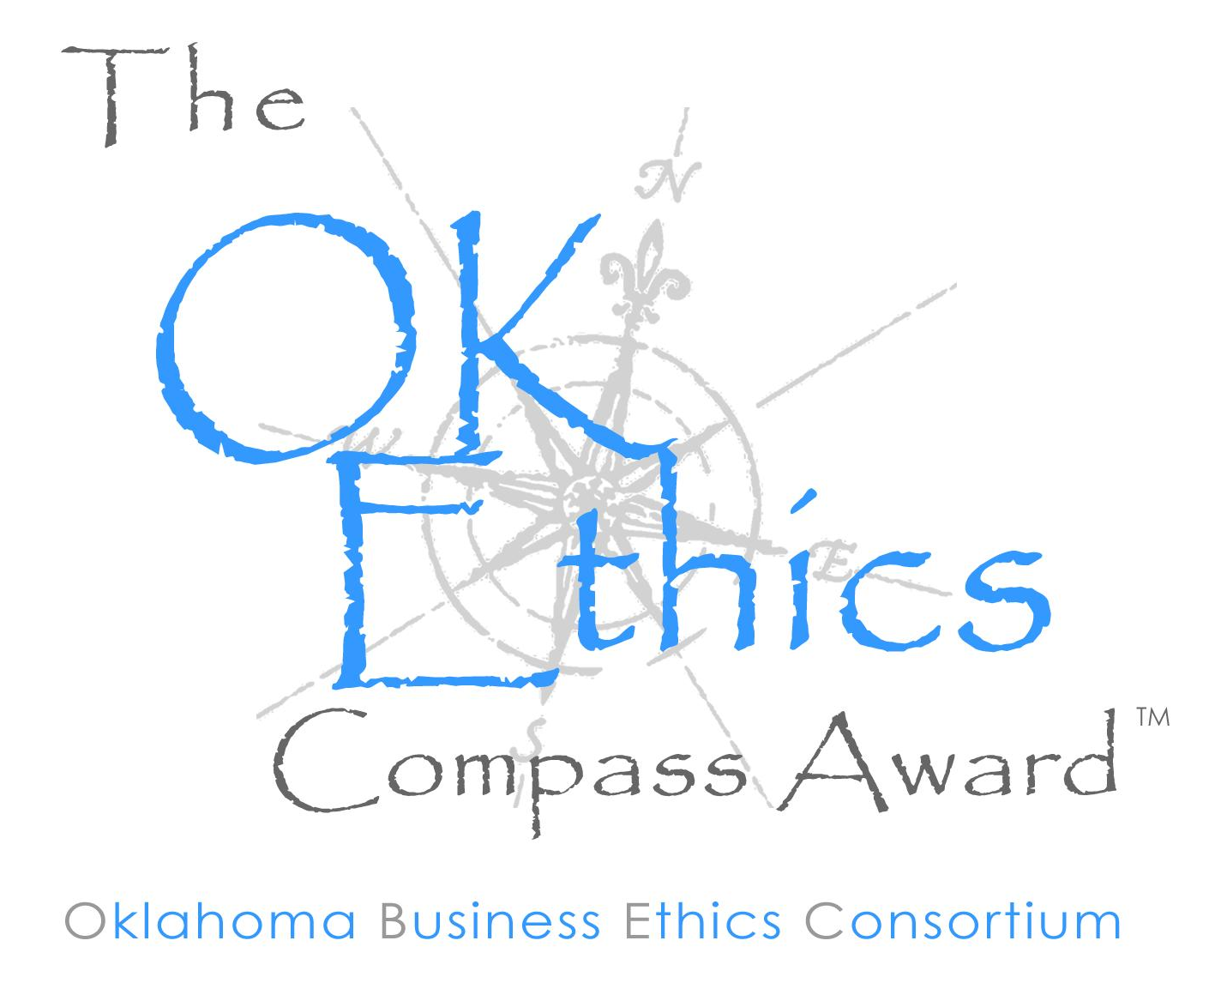
  - Lieutenant Governor Jari Askins will provide opening remarks, followed by executives from award-winning companies!

- GUEST SPEAKER:
2006 OkEthics Compass Award Recipient for the
Large Company Category:
Rick Wagner, Horizon Member and
Partner-In-Charge with Eide Bailly (OKC & Tulsa)

- UPCOMING CONSORTIUM EVENTS – Advance reservations required for all events www.okethics.org or call 858-2233
Member discounts apply regardless of location.
OCU – Student Chapter – Special Event!
February 20 - 5:30 to 6:30; “Ethics in Politics” presented by Burns Hargis, Vice Chairman, Bank of Oklahoma N.A.; held at the Kerr McGee Auditorium in the Meinders School of Business on the Oklahoma City University campus. Free to OkEthics members – contact Jenny Martin at 203.2185 or via email at jenny.martin@martinbionics.com.

Norman Chapter
February 21 – Terry Hobson, Vice President of York International/Johnson Controls
presents “Ethics in Management”
Volunteers needed in Norman; Call Norman Chapter President,
NOTE: Members of the Oklahoma Business Ethics Consortium frequently share information concerning various issues and developments that may have legal implications. The discussions, commentary, and handouts at Consortium meetings or presentations to other organizations are for general informational purposes only. They cover only some aspects of the subject topic, and do not constitute a complete legal analysis of the topic or how it might apply to any particular set of facts. Before taking any action based on information presented by a Consortium member, participants are encouraged to consult a qualified attorney. The observations and comments of presenters at Consortium meetings and networking are the views and opinions of the presenter and do not constitute the opinion or policies of the Consortium or any of its members.
___________________________________
YOU MAY REGISTER FOR ANY UPCOMING PROGRAMS THROUGH OUR WEBSITE AT www.okethics.org OR CALL 858-2233.

Contact Buck Irwin with Nextep at birwin@nextep.com
Tulsa Chapter
February 22 – Women Business Owners Panel:
Dana Weber, CEO of Webco Industries, Inc;
Cari Marshall, COO, L & M Office Furniture;
Deborah Brazeal, President of Infinity Care of Tulsa;
Lynn Flinn, EWF International & The Rowland Group
March 29 – Gary Paxton,
CEO of Dollar Thrifty Rent-A-Car

OKC Chapter
March 14 – Jay Martin, new Site Director for
Dell, Inc - OKC
APRIL 25 – OkEthics Statewide Conference &
Compass Awards

May 9 – Oklahoma Centennial Commission
Director, Blake Wade

VII. Other Programs Related to Ethics

Character First – Business Leaders Breakfast/Luncheon
Discernment: Understanding the deeper reasons why things happen
Tuesday Breakfast, February 27, 2007—7 A.M. to 8 A.M.
Thursday Luncheon, March 1, 2007—12 P.M. to 1 P.M.
RSVP: 815-0001 or visit the Character Council Website at http://www.characterok.org/

Special Request: Character First needs mentors to support their education initiatives at the grade school level. If you are interested in volunteering, please contact Chad Christiansen at 815.0001, ext. 213 or via email at
cchristiansen@characterfirst.com (Brochures are available on the back table.)

Oklahoma Center for Nonprofits – Oklahoma Standards for Excellence
Oklahoma Center for Nonprofits is one of only ten organizations to be accepted as a replication partner by the National Standards Institute. This program, which is intended to give Oklahoma nonprofits the tools and knowledge to be even more effective in pursuing their missions.
Contact the Center at http://www.oklahomacenterfornonprofits.org/standards.asp
What are the Standards?
1) Eight guiding principles and 55 performance standards
2) Core values of honesty, integrity, fairness, respect, trust, compassion, and responsibility
3) Basis for self-assessment
4) Model for best practices
5) Empowerment tool to help nonprofits meet the highest standards of nonprofit governance, management, and
operations
6) Code for self-regulation for the nonprofit sector
VIII. SPECIAL ANNOUNCEMENT & INTRODUCTION: Brent Gooden, The Gooden Group

IX. KEYNOTE SPEAKER Tom Ward, CEO of SandRidge Energy

X. ADJOURN 1:00

PLEASE HELP US CONTROL COSTS BY LEAVING YOUR NAME TAG HERE!

