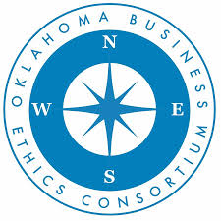

Are you an experienced leader who is seeking an opportunity to make a positive impact on the future of Oklahoma and beyond? Do you enjoy bringing people together for meaningful dialogue? If yes, we would like to connect with you.

The Oklahoma Business Ethics Consortium (OK Ethics) is a non-profit organization consisting of business professionals and academic leaders dedicated to the promotion of integrity in the workplace. Since its launch as a small discussion group in 2003, OK Ethics has grown into one of Oklahoma’s largest communities of workplace leaders. Today, the Oklahoma City based organization includes over 500 individuals representing approximately 150 companies, non-profits and Academic entities from throughout the State of Oklahoma.

OK Ethics’ purpose is to continually encourage, inspire and equip leaders and professionals in their endeavors to foster a culture of ethical behavior. Recognizing the value of community, OK Ethics hosts regular forums with influential speakers and expert panels in Oklahoma City and Tulsa focused on timely ethical issues of interest to a broad range of professionals. To reinforce best practices, OK Ethics offers an annual awards program to recognize organizations and individuals who have demonstrated a strong commitment to promoting integrity in our communities, campuses and workplaces.

The OK Ethics Board is seeking a full-time Executive Director who will assume the oversight of the non-profit, which includes the administrative tasks, operations capacity, program management and strategic leadership needed to grow the organization. Leading a small team of part-time staff, the Executive Director actively promotes workplace ethics and endeavors to build a community of professionals committed to ethical practices. OK Ethics has a dedicated Board and volunteers and is poised for growth.

To learn more about the role, please visit the OK Ethics website at okethics.org. Applications are being accepted until 2:00 pm (CST) on Thursday, July 11th. Resumes can be sent confidentially via email to: okethicsmail@okethics.com. The salary is competitive and commensurate with the experience of the candidate.

